**DIP Project 3**

**電信碩 沈衍薰 309513047**

1. Source code

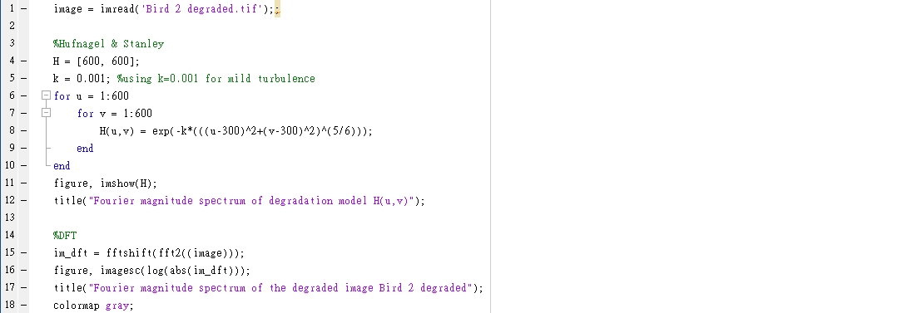

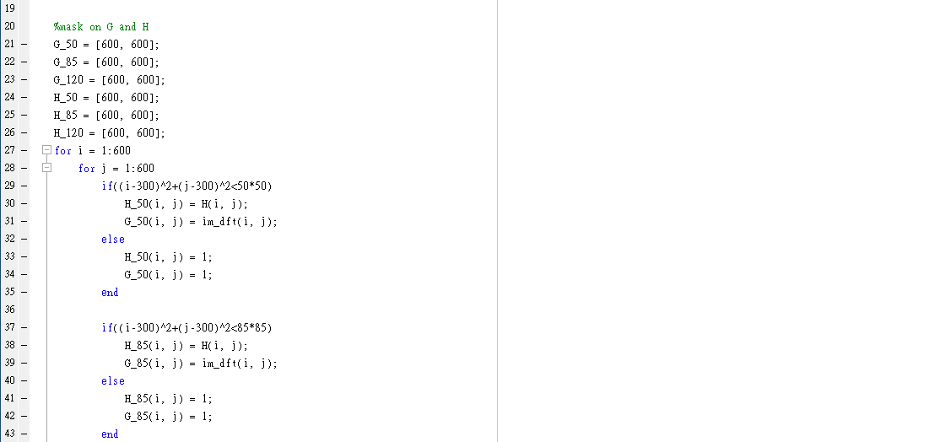

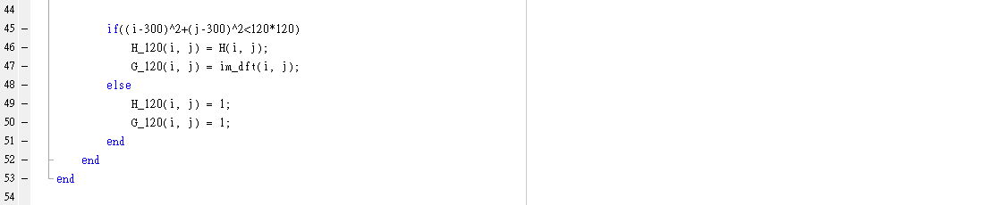

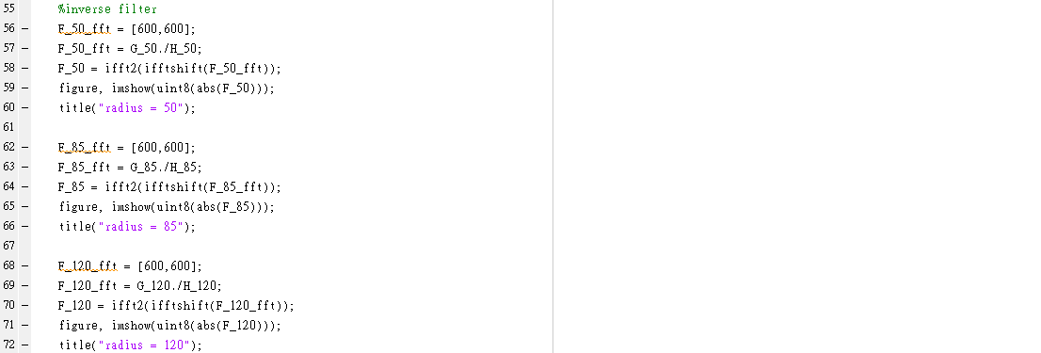

1. Figure of the Fourier magnitude spectrum of the degraded image Bird2 degraded

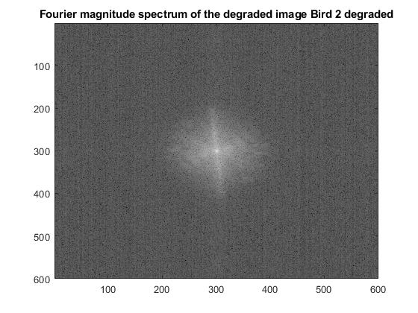

1. Figure of the Fourier magnitude (frequency response) of degradation model H(u,v)

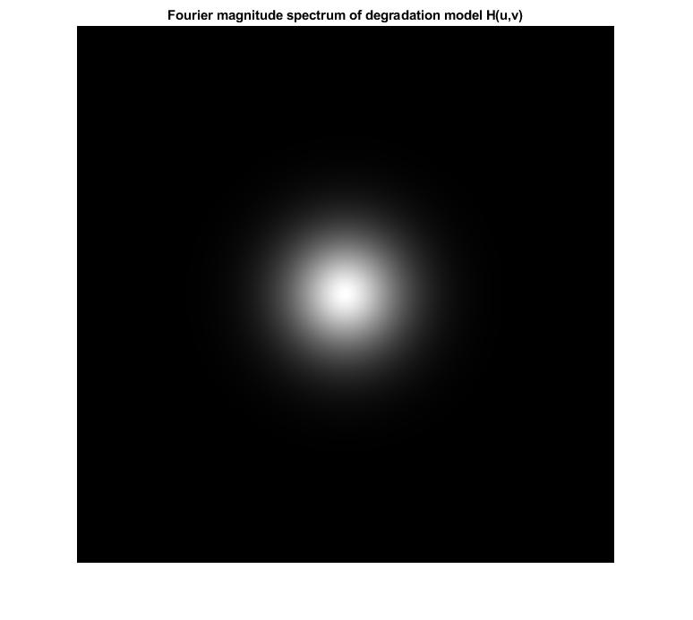

1. Figures of the output images using different radii (50,85,120) of inverse filtering

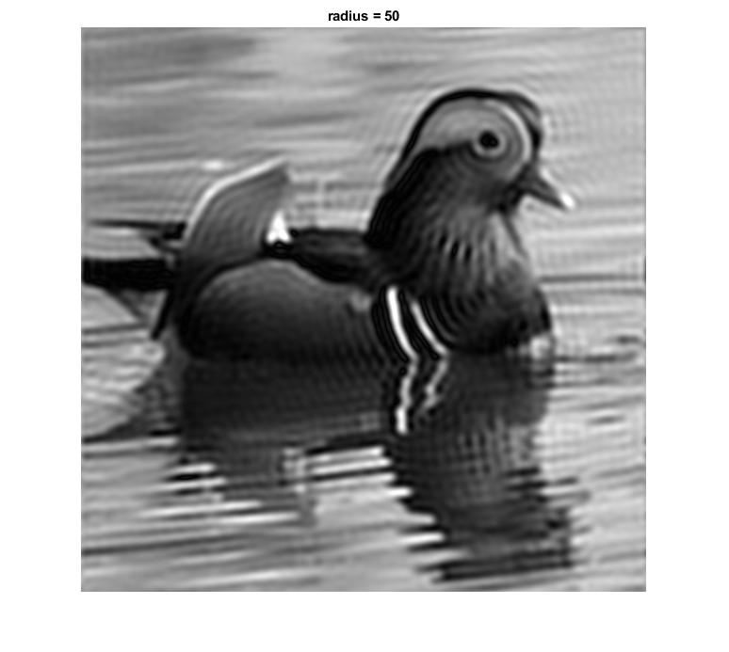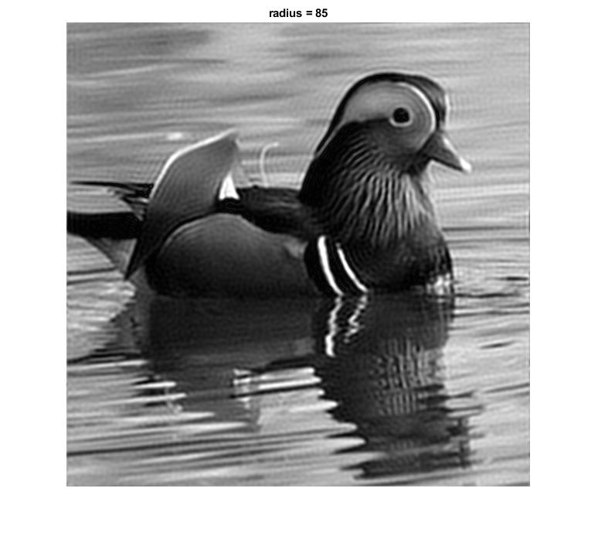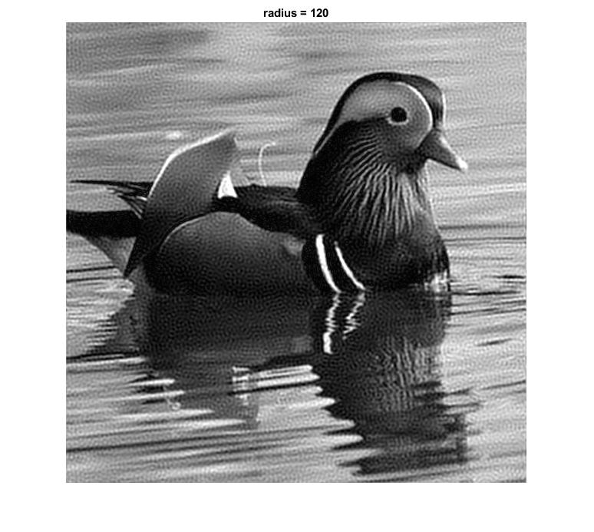

1. Model parameter k

For mild atmospheric turbulence, choose k=0.001